
Help Manual

Contents
1. Overview 2
2. Home 3
2.1. Assign a Project Name 3
2.2. Reference Style 3
2.3. Upload Files 4
2.3.1. Cross Button (×) 5
2.3.2. Reset Button 6
2.3.3. Submit Button 6
3. Card Page 7
3.1. Online Edit Button 9
3.2. Full Report Button 10
4. Manage 12
4.1. View Button in Action Menu. 12
4.2. Download Button in Action Menu 13
4.3. Edit Button in Action Menu 14
4.4. Delete Button in Action Menu 14
4.5. Search 15
5. Account 15
6. Logout 16

1. Overview
The Confirm+ system is designed to assist authors and publishers in ensuring the completeness and accuracy of manuscripts before they are submitted for publication. The system aims to provide valuable feedback to authors by automatically detecting missing and incomplete elements in their manuscripts. By doing so, it helps authors enhance the quality of their work, reduces the chances of rejection by publishers, and accelerates the publishing process.

The Confirm+ system contains three tabs, as listed below:
- Home
- Manage
- Account

2. Home
The "Home" tab is the first page you encounter upon logging into the system. It serves as the central hub for assigning the name of the project, selecting the reference style, and uploading the manuscript.
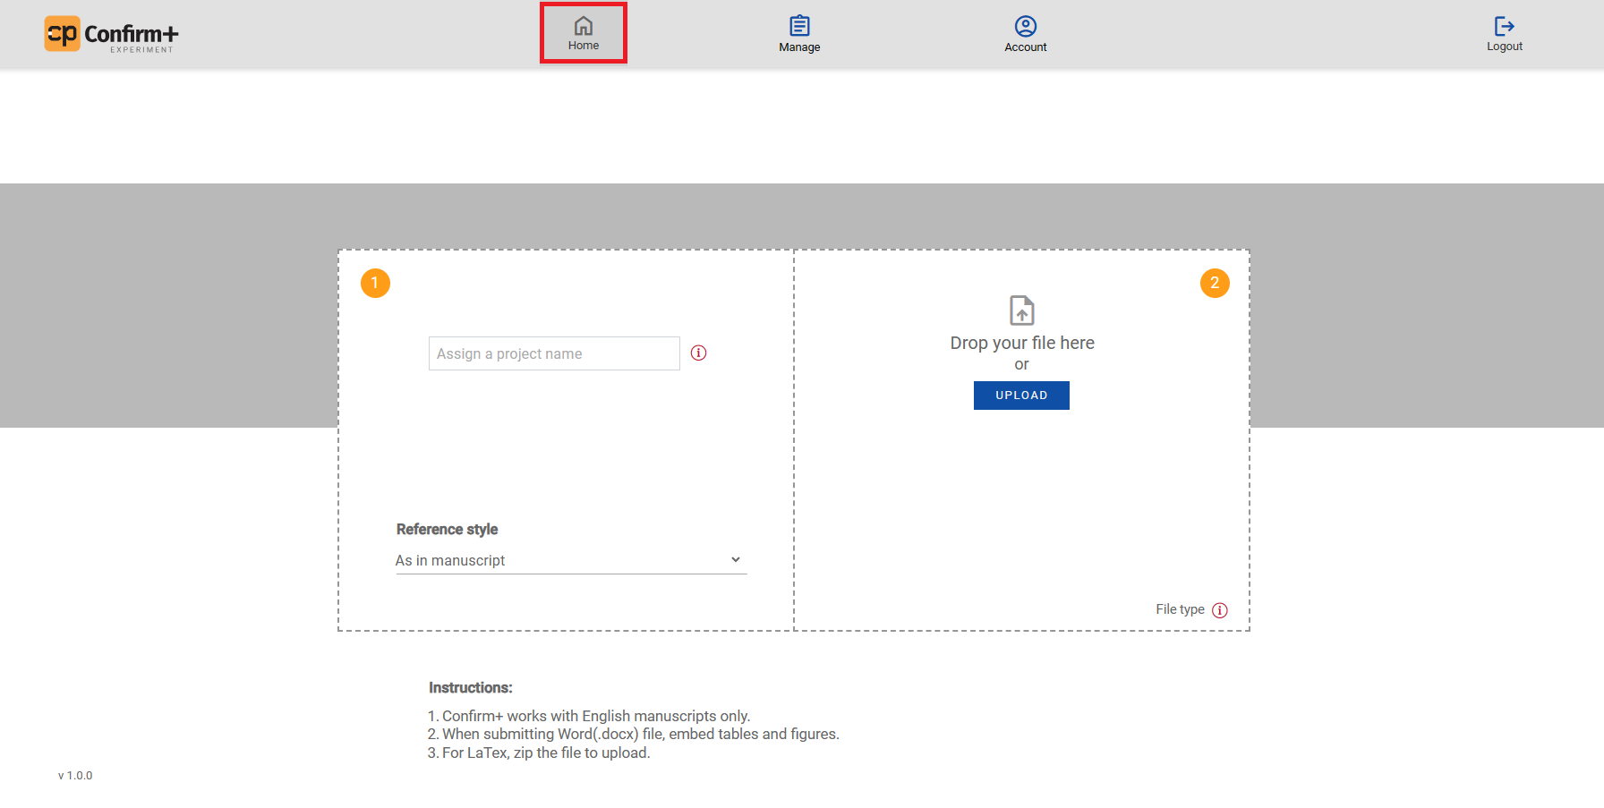
The Home tab has the following modules:

2.1. Assign a Project Name
Assigning a project name is crucial for easy tracking, managing, and retrieval of the manuscript.
Enter a project name adhering to the following validations:
- The project name is mandatory for submitting the manuscript.
- Spaces and special characters are not allowed.
- Maximum of 15 characters.

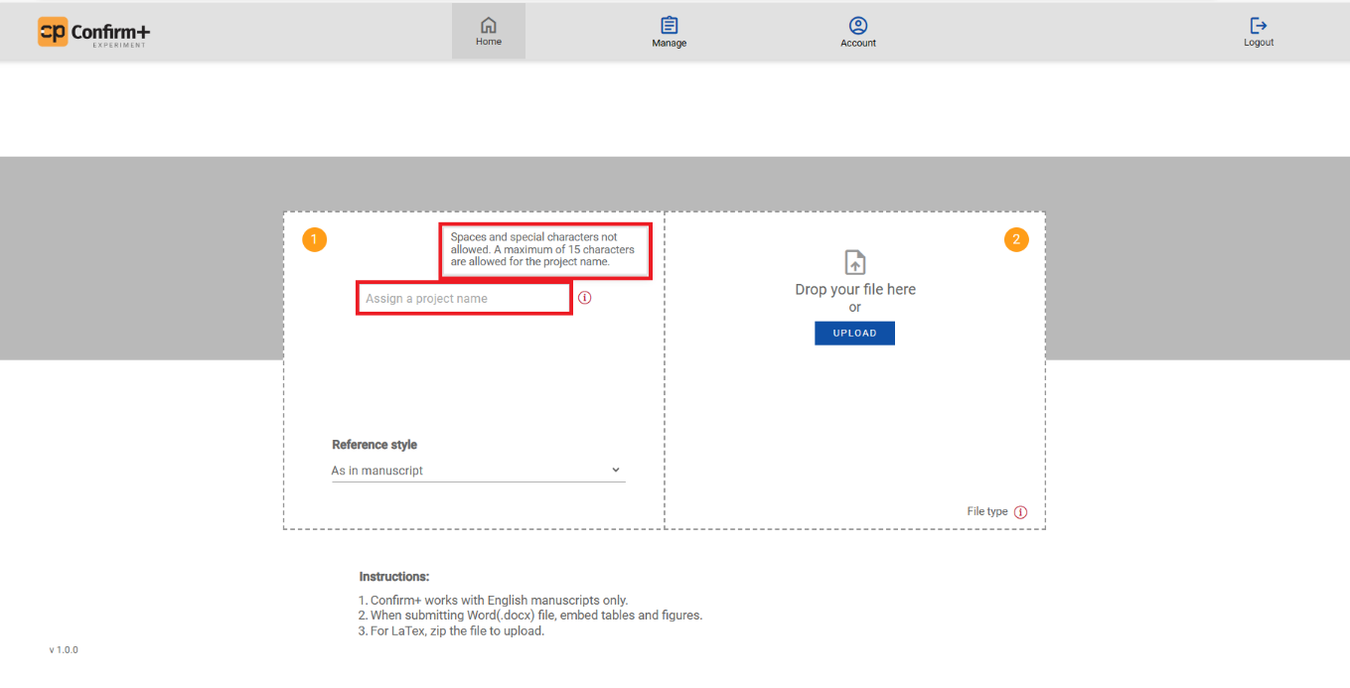

2.2. Reference Style
Selecting a reference style is essential for ensuring your manuscript maintains consistent, error-free formatting, adheres to established guidelines, and presents a professional appearance. It not only saves time but also guarantees uniformity in your citations.

To choose your desired reference style, follow these steps:
- Navigate to the reference style selection in the system.
- Click on the drop-down menu.
- You will find "As in manuscript" as the default option along with ten other reference style choices.

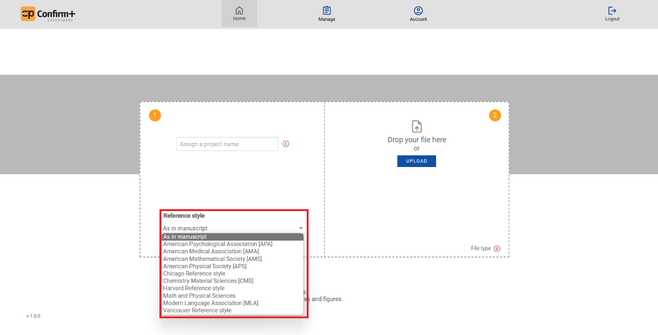

2.3. Upload Files
Uploading a manuscript as an input file ensures proper reference formatting, completeness of all elements, and readiness for publisher submission.
There are two options for uploading the manuscript:
- Upload Button: Click "Upload" to select a file from your local storage.
- Drag and Drop: Alternatively, drag and drop your file into the designated area.
Our platform supports two manuscript formats:
- Docx Format: Upload your manuscript in Word (.docx) format, integrating figures and tables within the same document.
- LaTeX Format (ZIP Archive): You can also upload your manuscript in LaTeX format by compressing it into a ZIP archive before uploading.
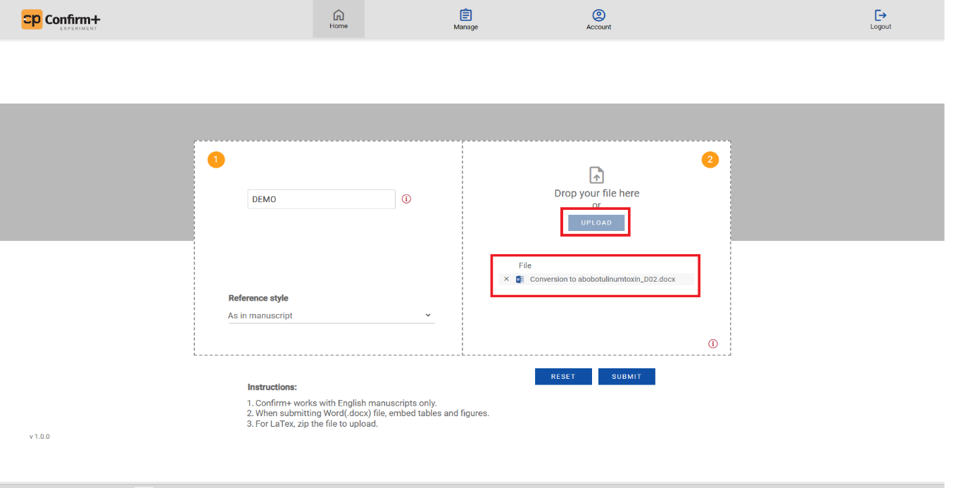

Once the file is uploaded, we can use the following functionalities:

2.3.1. Cross Button (×)
To delete an uploaded file:
- Locate the uploaded file.
- Click the cross button (×) to remove it.

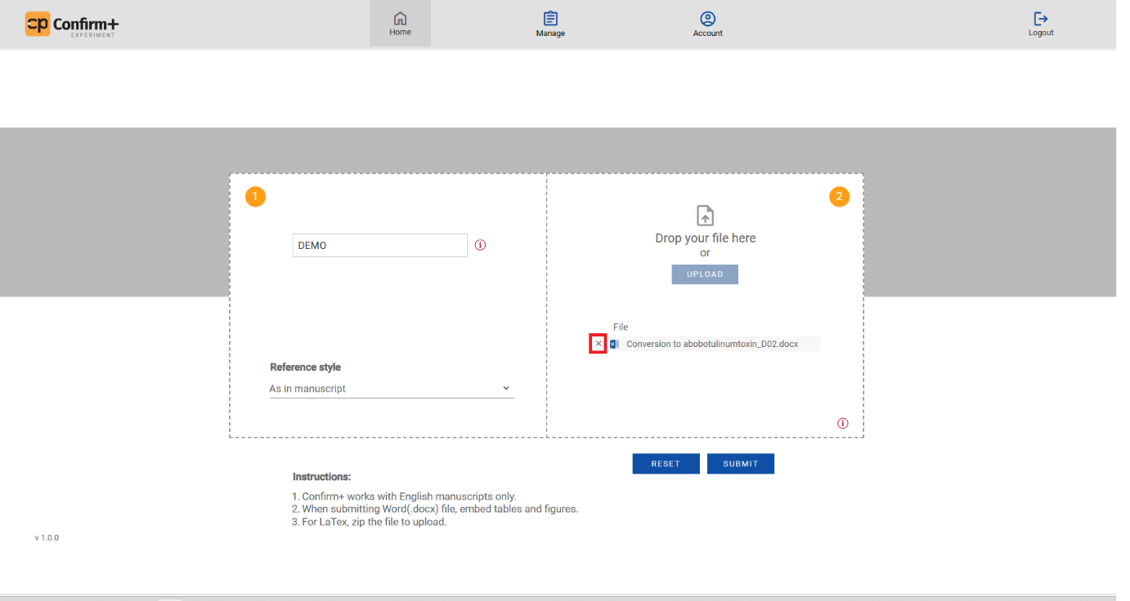

2.3.2. Reset Button
Clear the inserted data easily:
- Click the reset button to clear the input fields.

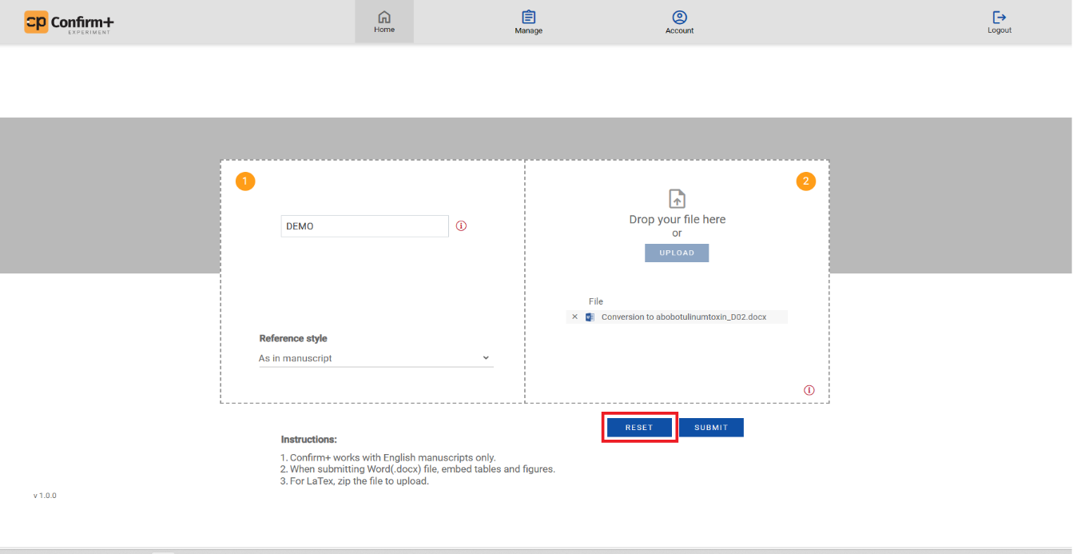

2.3.3. Submit Button
Start the process using the submit button:
- Click Submit to initiate the process.

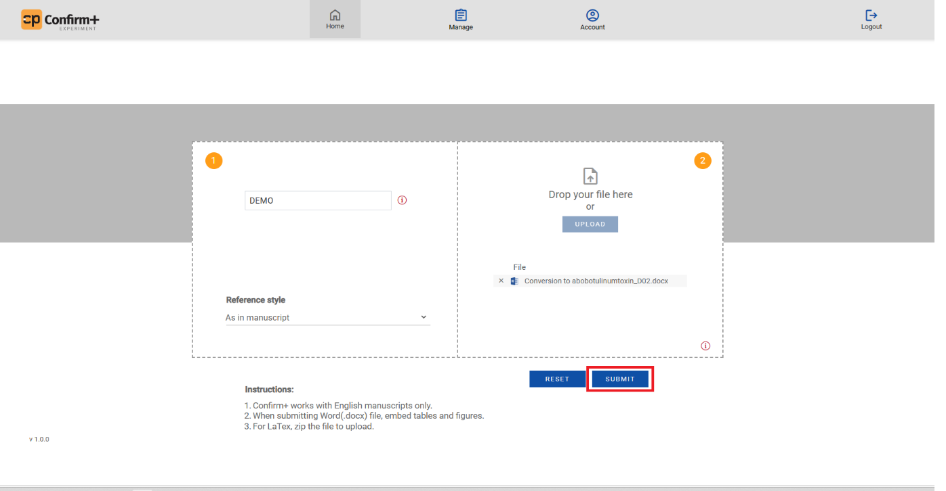

3. Card Page
After submitting your manuscript, you will be directed to the Card Page, which displays five distinct cards, each representing a different stage of the processing workflow:

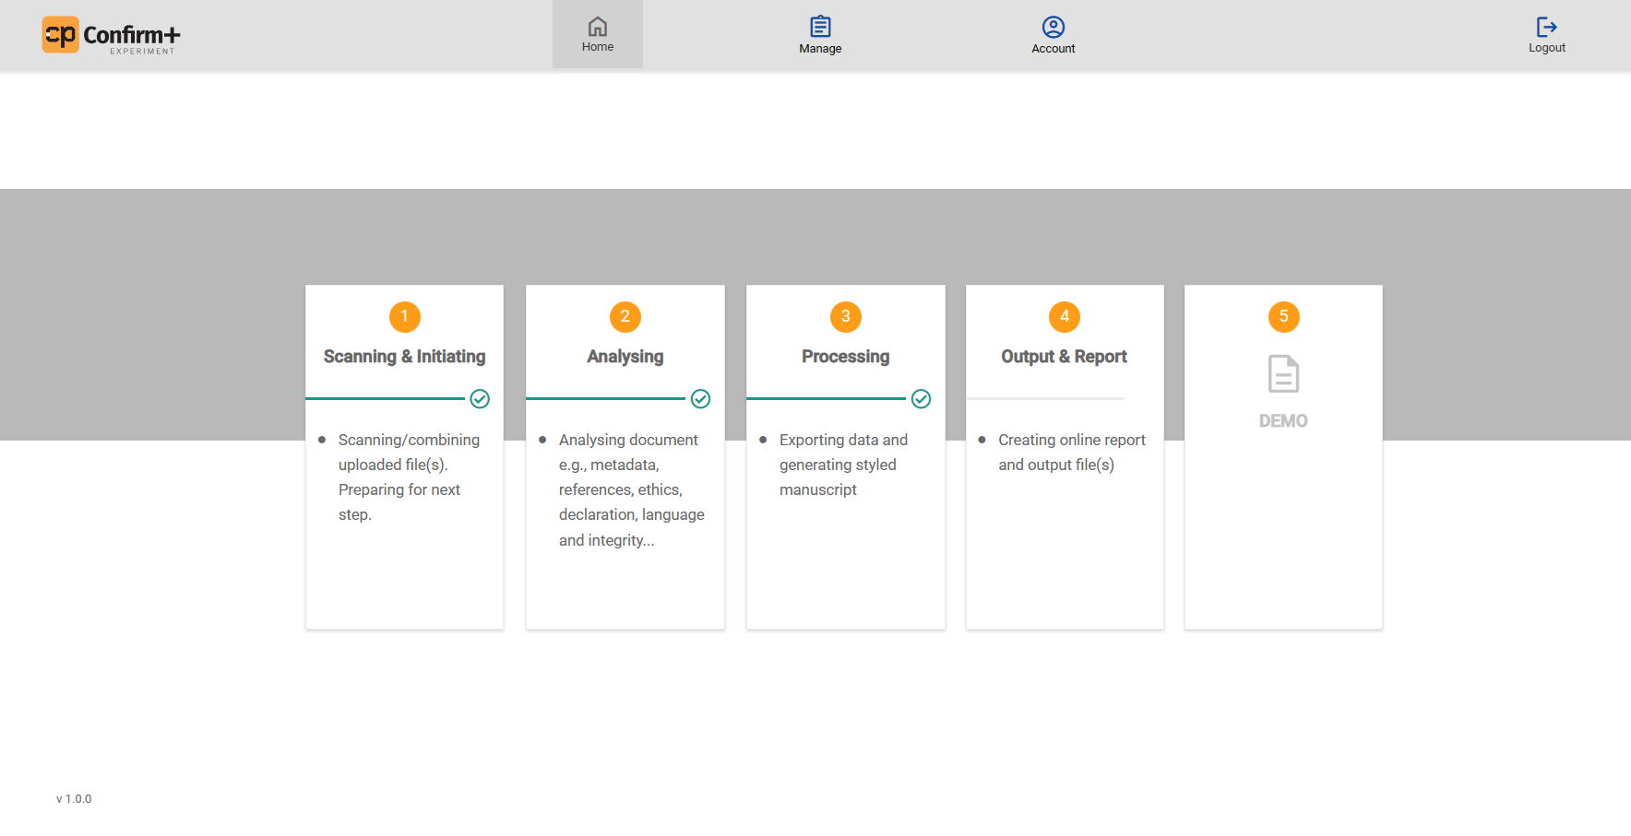

- Scanning and Initiating Card:
In this initial stage, the system performs scanning and file consolidation tasks, preparing the
uploaded file for the subsequent steps in the process.

- Analysing Card:
This stage involves a detailed analysis of the manuscript. The system scrutinizes various
aspects, including metadata, references, ethical considerations, declarations, language, and
overall document integrity.

- Processing Card:
During this stage, the system exports data and generates a professionally styled manuscript, ensuring that it meets the specified guidelines and formatting requirements.

- Output and Report Card:
The Output and Report Card focuses on the creation of online reports and output files. This
step ensures that the processed manuscript is ready for presentation.

- Project Card:
The Project Card is the final stage of the processing workflow. Here, you are presented with
the following options:
- Format Indicators: A tick (ü) symbol appears if the uploaded file was in Word format, and a cross (û) symbol for LaTeX (and vice versa for LaTeX format).
- Download Icon: Download symbol to retrieve the Auto-Styled Manuscript.
- Delete Icon: Delete icon to remove the Auto-Styled Manuscript.
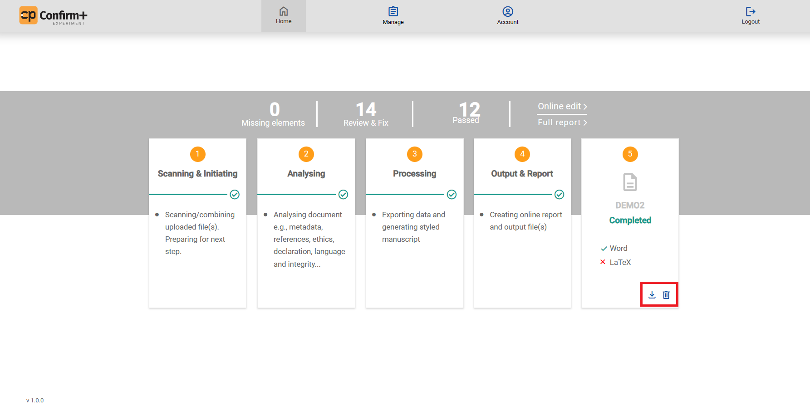

Once all processing steps are complete, the Card Page offers two options:
- View Full Report: Access the comprehensive report.
- Make Online Edits: Edit the Auto-Styled Manuscript.

Additionally, the Card Page displays details on missing elements, items to review & fix, and successfully processed items.


The Card Page serves as a centralized hub for monitoring and managing the progress of your manuscript through the various stages of processing, ensuring that it meets all the necessary criteria and is ready for further use.

3.1. Online Edit Button
- Use the 'Online Edit' button to access the online editor for making final edits if needed.
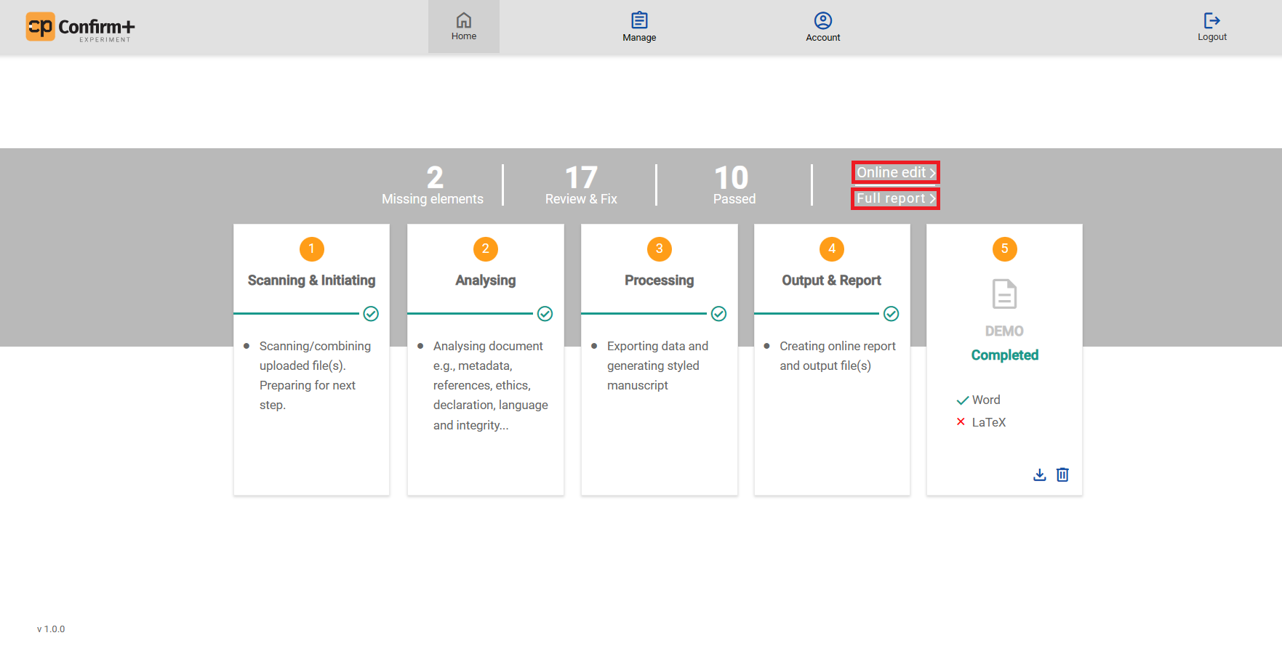

- You can choose whether to accept or reject any changes made by the system in the online editor.

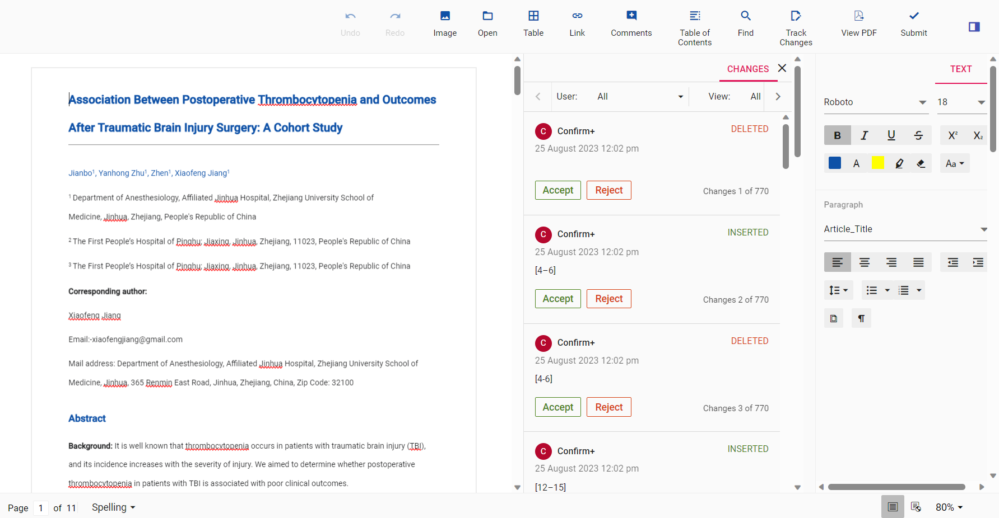

3.2. Full Report Button
- Access the complete report using the ‘Full report’ button.

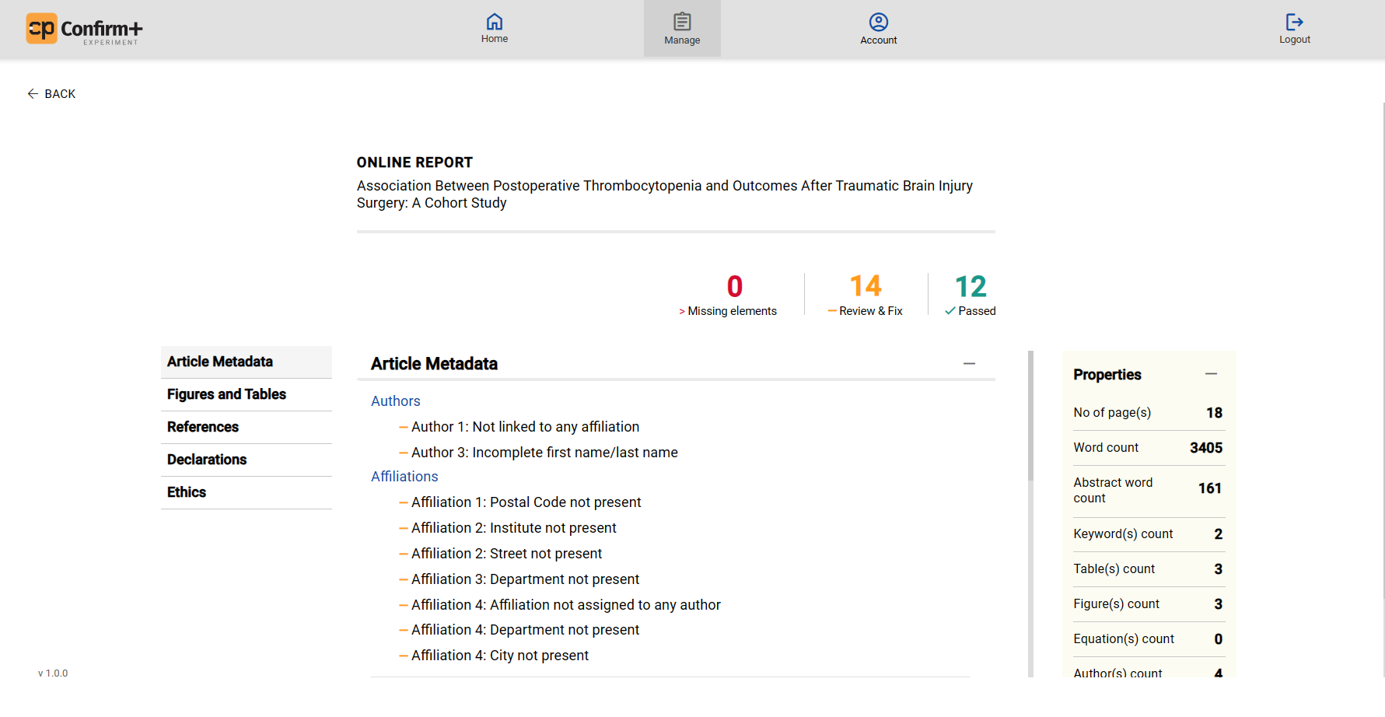

- The online report provides the following information:
- Missing Elements- Elements missing in the manuscript are indicated by the following symbol: [ > ]
- Review and fix- Elements that require review and correction are marked with the following symbol: [—]
- Passed- Elements that are accurate and do not require any further review or corrections are represented by the following symbol: [ü]

- The online report comprises five sections, which are accessible in the left pane:
- Metadata
- Figures and Tables
- Referencing
- Declarations
- Ethics
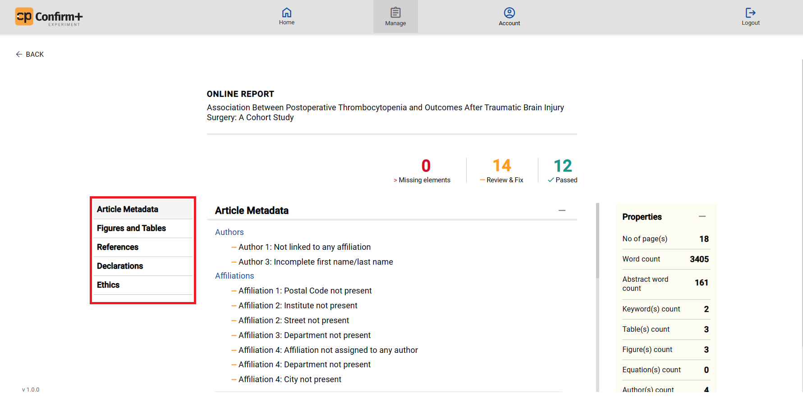

- In the right pane, find additional manuscript properties like page count, word count, abstract word count, keywords count, tables count, figures count, equations count, author count, affiliation count, and reference count. Expand or contract properties using the (+) and (−) symbols.
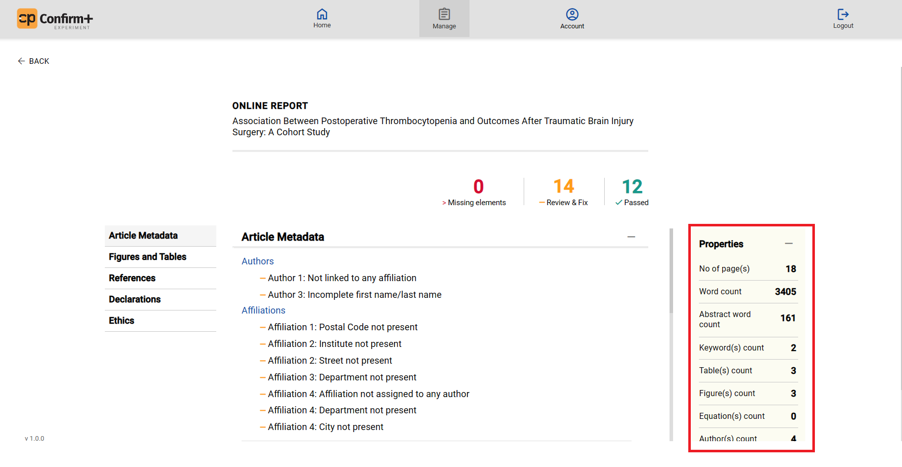

4. Manage
The Manage tab provides an overview of your projects and displays a list of previously uploaded files.

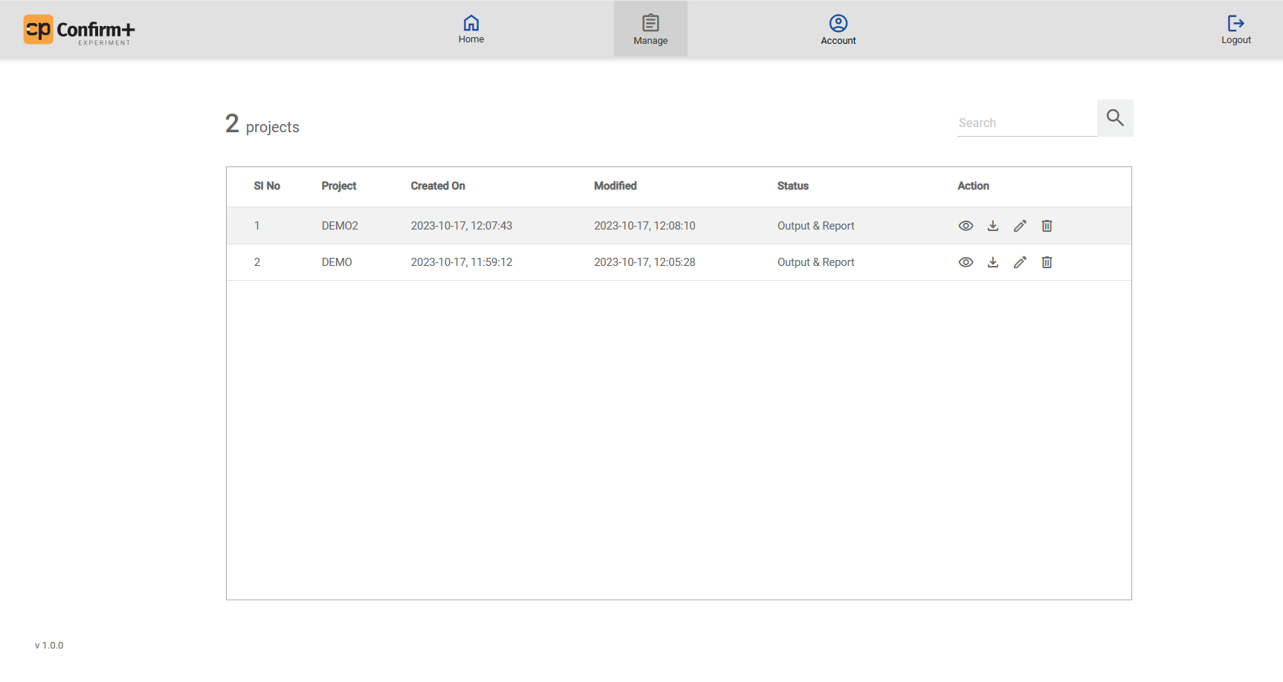
The functionalities provided in the Manage tab (under Action Menu) are as follows:
- View
- Download
- Edit
- Delete
Here, you can access your list of uploaded files and utilize these functions for efficient project management.

4.1. View Button in Action Menu.
The "View" button in the Action Menu allows access to the online report for the selected project.
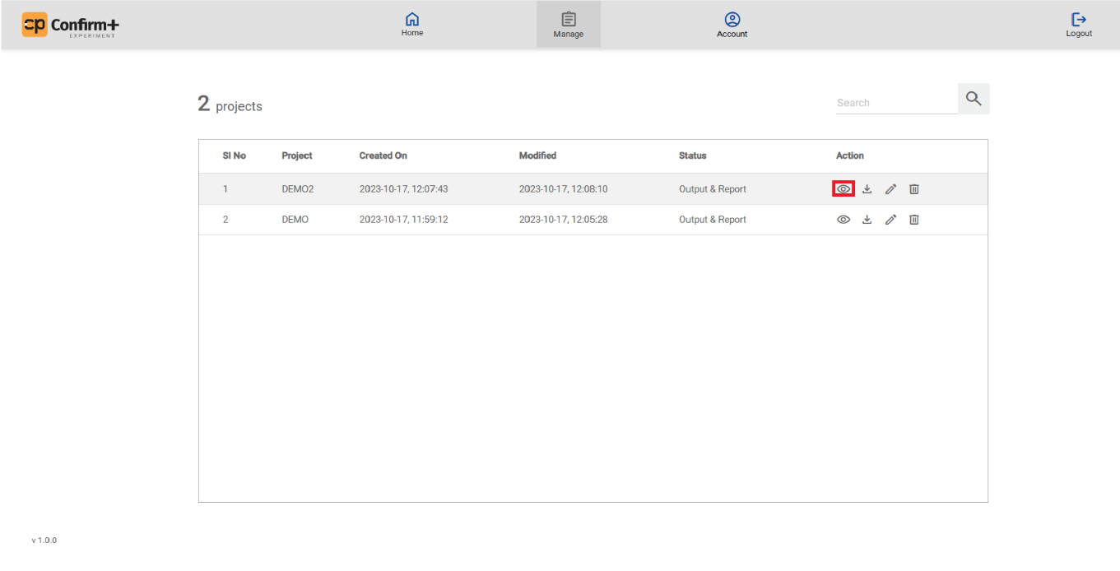
To return to the Manage tab from the online report, use the "Back" button within the report interface.

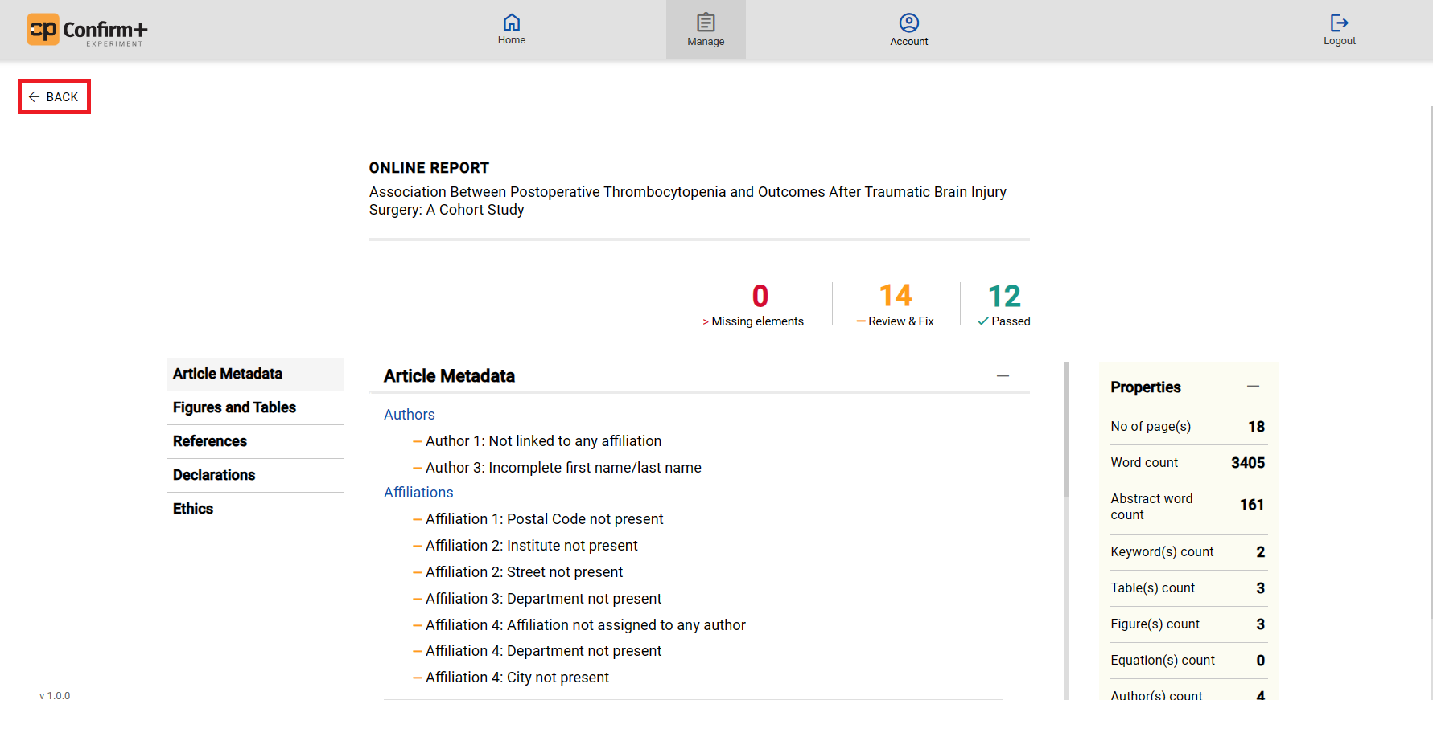

4.2. Download Button in Action Menu
Use the download button to retrieve the auto-styled manuscript in a zip package for your selected project.
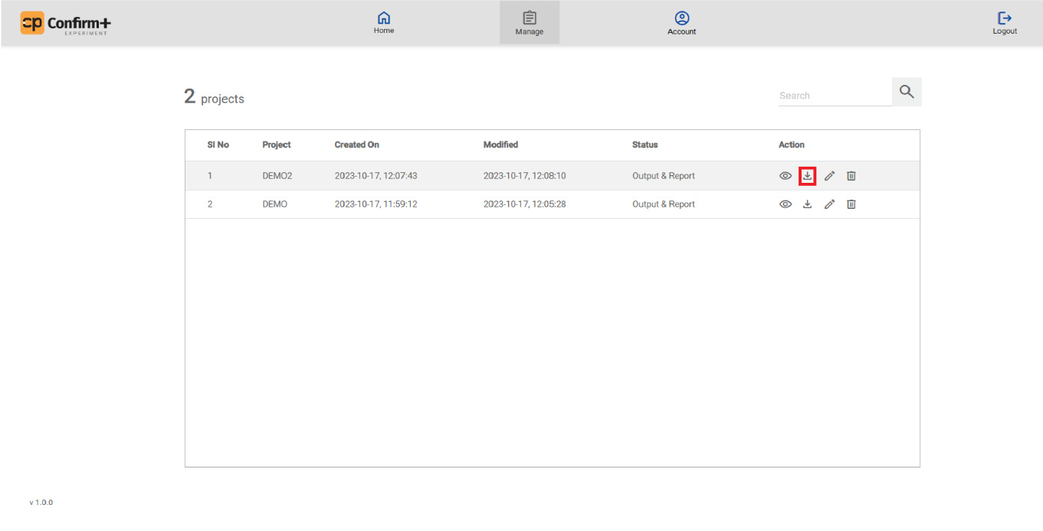

4.3. Edit Button in Action Menu
Click the edit button to access the online editor for your selected project. This allows you to edit the auto-styled manuscript.
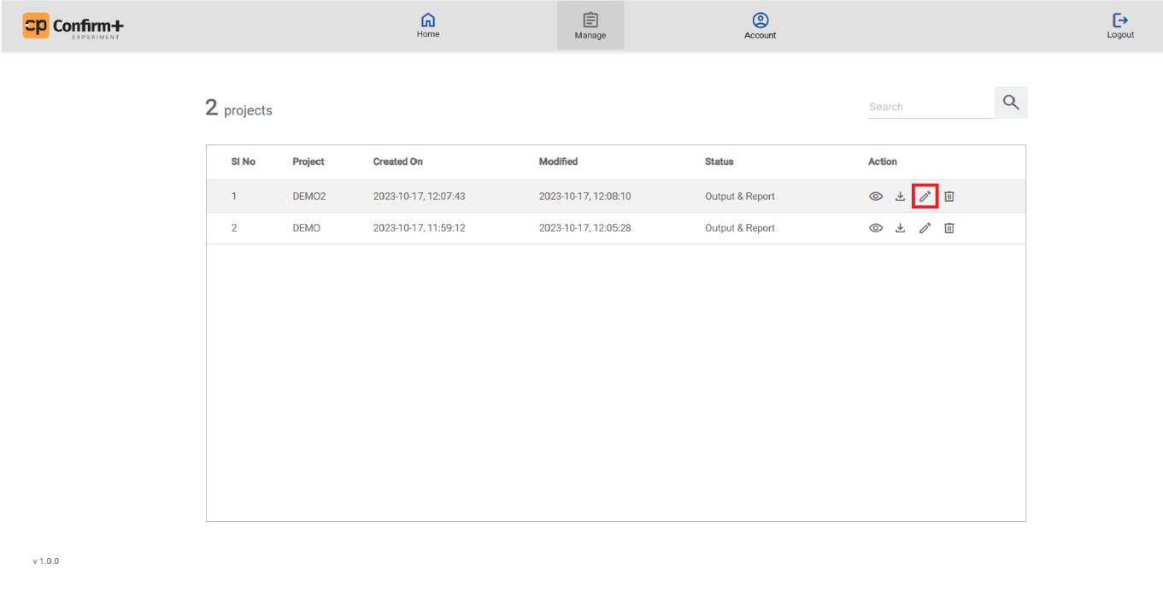

4.4. Delete Button in Action Menu
- Use the delete button to remove the project from the list.

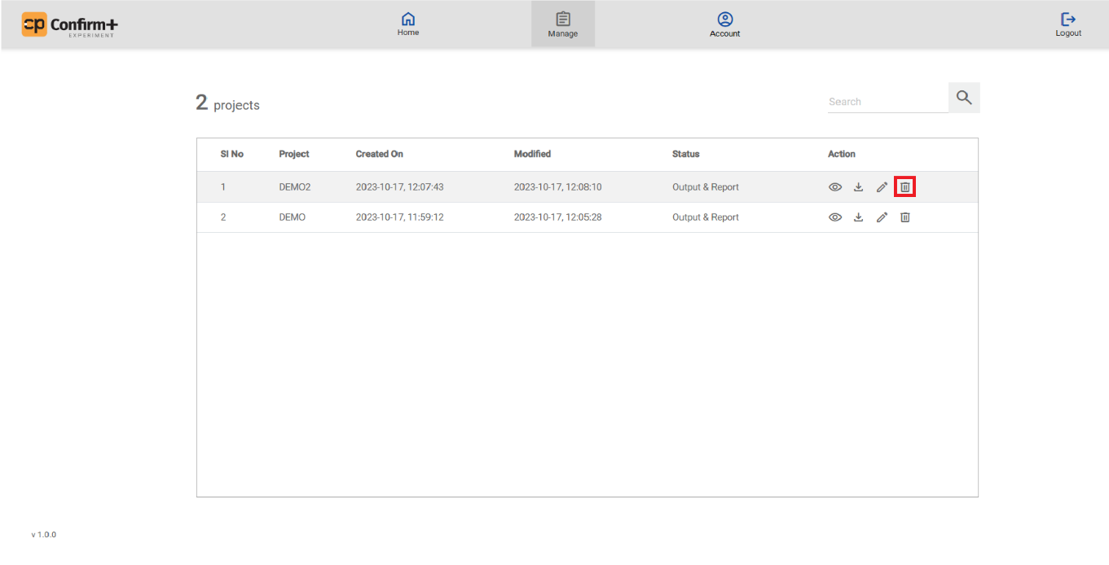

4.5. Search
Search for projects in the Manage tab:
- Enter the project name in the search bar to look for the required project.

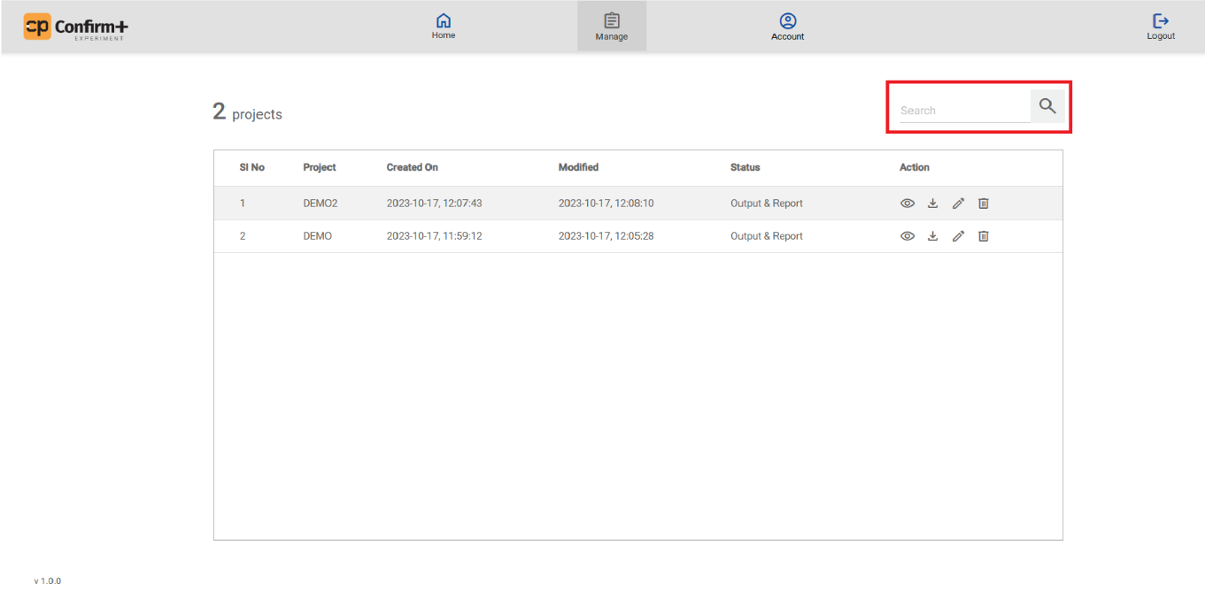

5. Account
In the "Account" tab, access your profile and change your password by clicking the "Edit" button in the relevant field.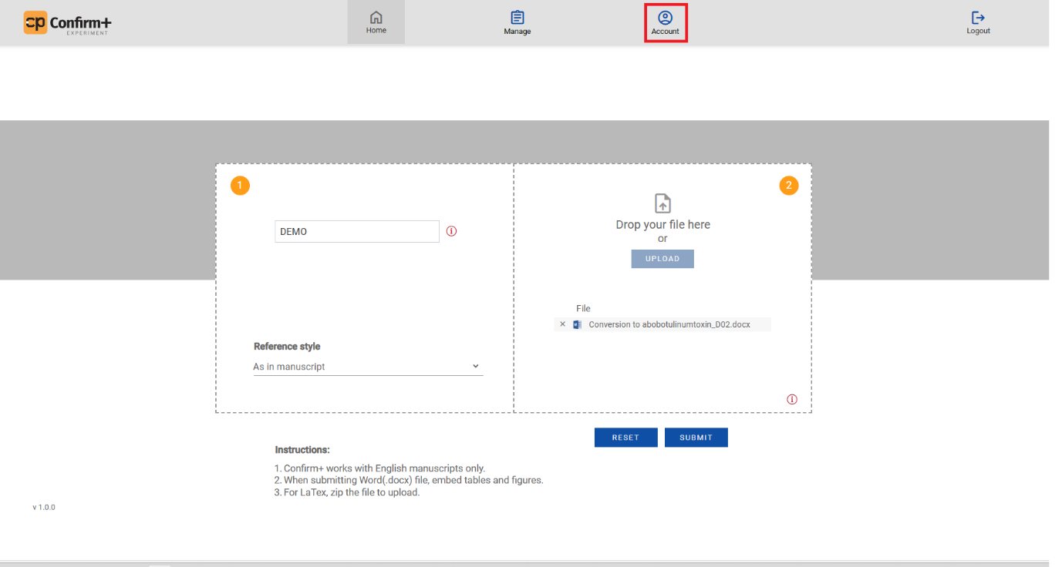
Accounts Page is given below:
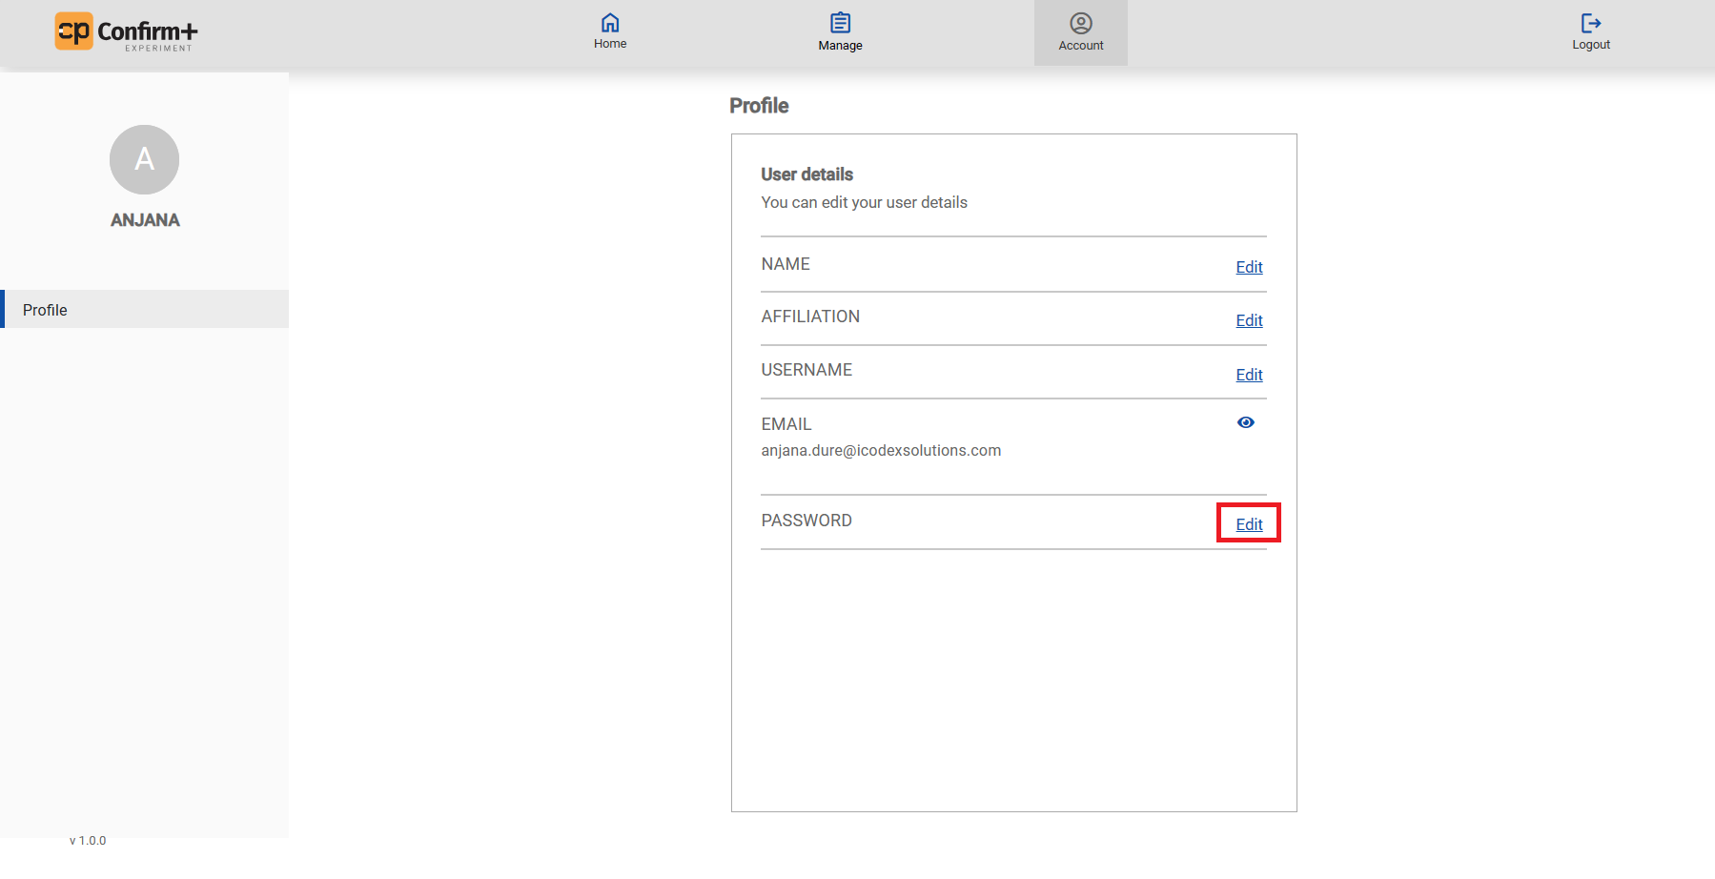
To reset your password, click 'Edit,' then enter your old password, new password, and confirm it in the pop-up window. Choose 'Submit' to reset or 'Cancel' to retain the current password.
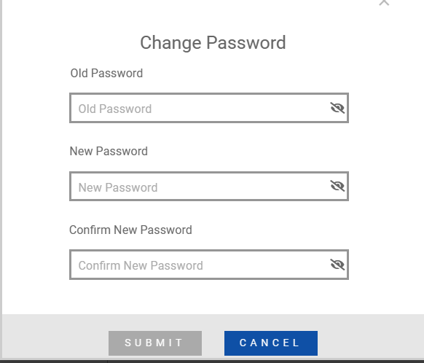

6. Logout
To log out from your account, simply click the "Logout" option located at the top right corner of the menu.
